Steps to create a Django Project

==========================

1) Open Command Prompt and Move to the Project Location .

2) To Create Project Type Command as

django-admin startproject <Project_name>

3) Move into Created Project Folder in command Prompt.

cd <Project_name>

4) Create a app in Project

Note : One Project can have any number of apps

django-admin startapp <app_name>

5) To Start the server

Note : Be into Project folder

python manage.py runserver

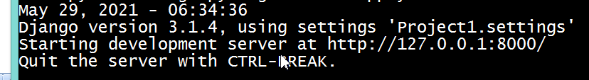

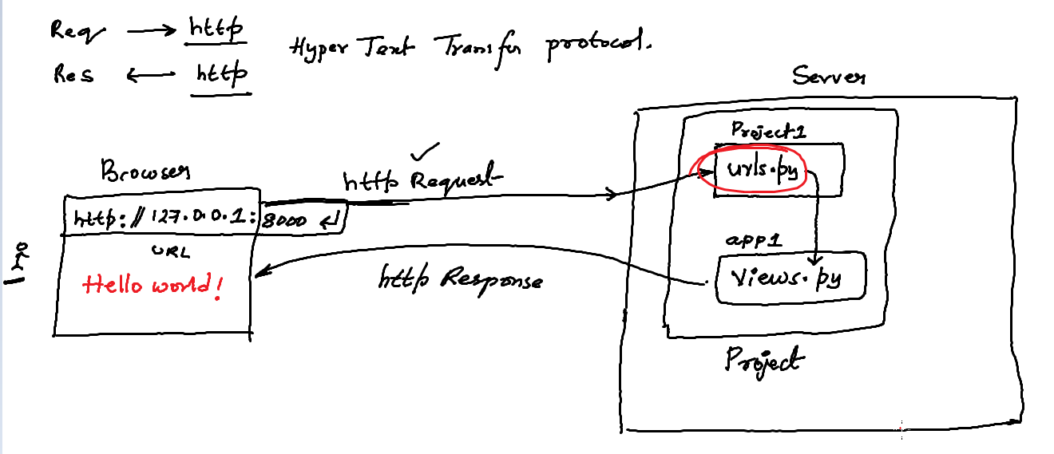

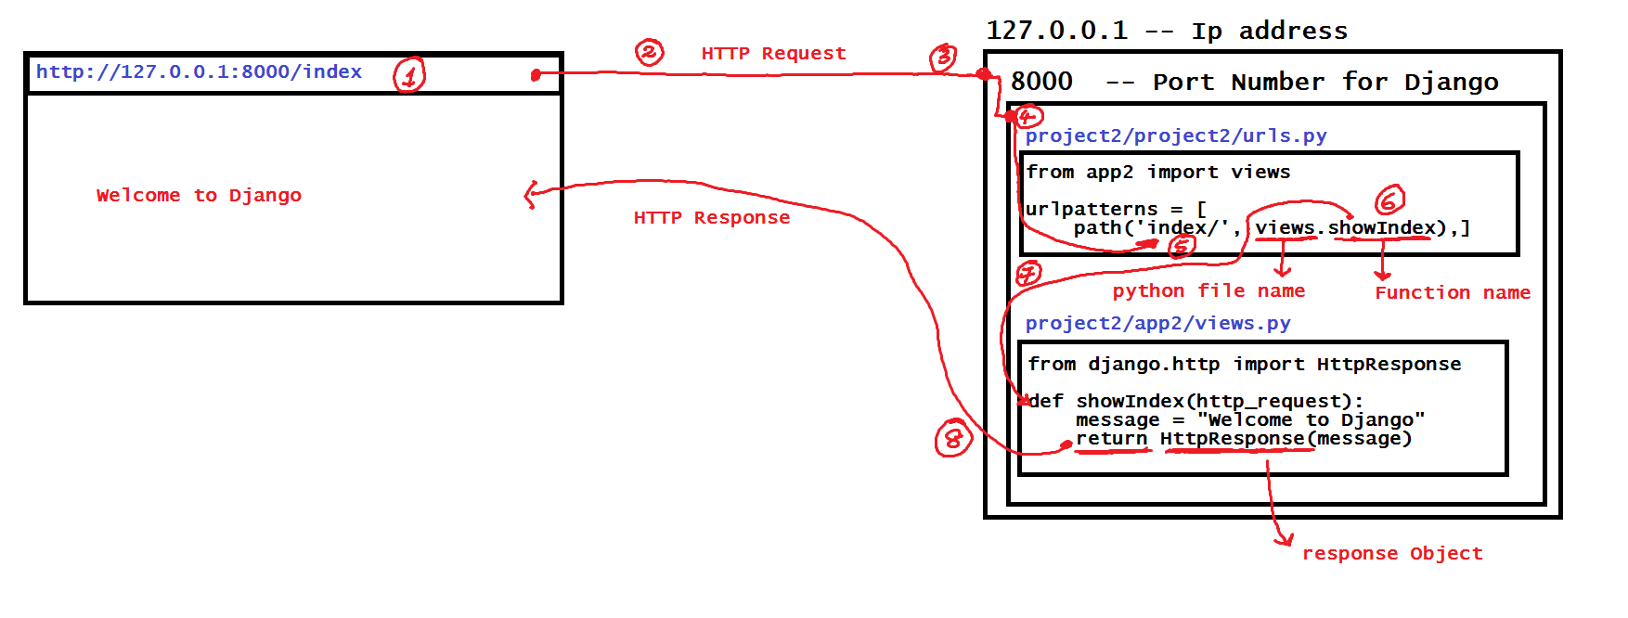

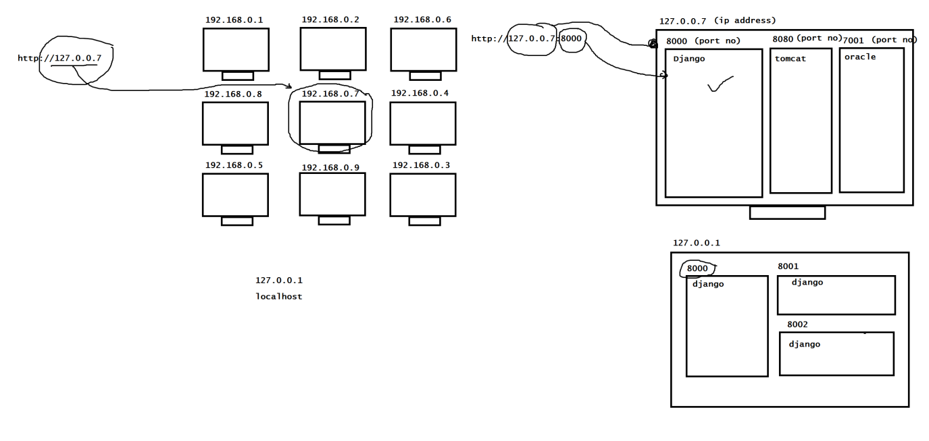

**Example with templates**

1) Create a project and create a app.

2) Move into the project folder and create a new folder name it as **"templates"**

3) add this "**templates**" folder into "**settings.py**" file

--> Project/Project/settings.py

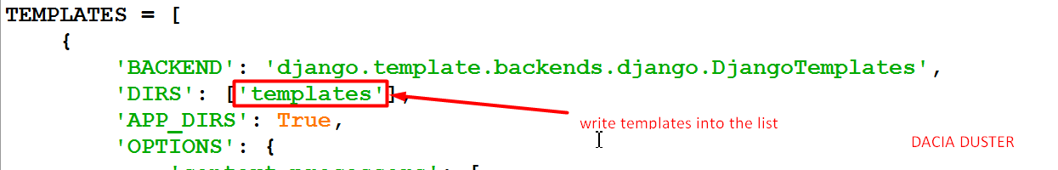

4) add "app" into the "INSTALLED APPS" in the same "settings.py" file.

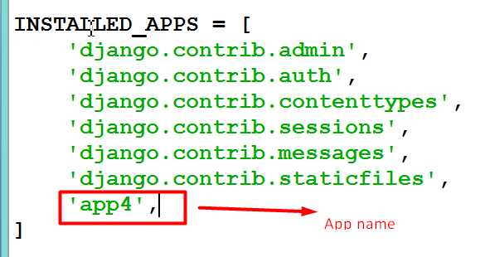

5) in templates folder creating a ".html" file

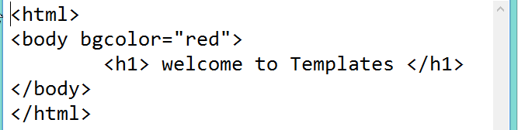

6) urls.py 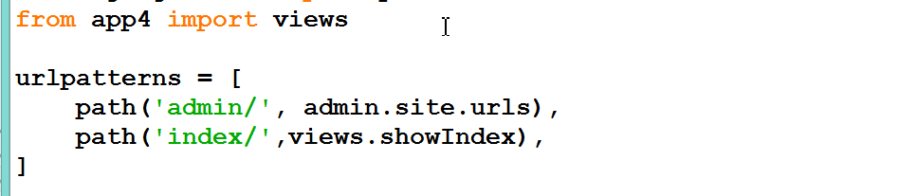

7)views.py

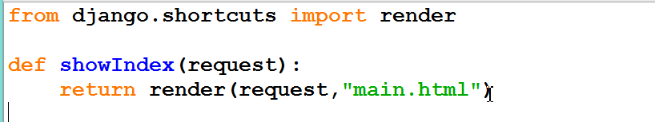

8) Start the server using command prompt and run the application using browser.